ADDRESS

BY

H.E. YOWERI KAGUTA MUSEVENI
PRESIDENT OF THE REPUBLIC OF UGANDA

TO THE NATION

UPDATES ON MATTERS
REGARDING CORONA VIRUS (COVID 19)

18TH MAY, 2020
NAKASERO

Countrymen and Countrywomen,

Greetings,

Once again, I am here, to update you on our common fight against the corona-virus that we launched on the 18th of March, 2020, even before a single case of that disease had manifested itself, at that time.

Between the 18th of March and the 30th of March, I announced a total of 35 drastic measures that involved most of the 42million people of Uganda: students, Church ─ Mosque worshippers, travelers, etc. I congratulate you and thank all of you in participating, willingly, in this battle.

As a consequence, even when the first case was discovered on the 21st of March, 2020, in the form of a returnee from Dubai that was discovered by our temperature monitor at the Airport operated by a Health worker, Lillian Babirye, we had already succeeded in dispersing our major population groups and the virus did not, it seems, succeed in penetrating our population. Here below are the daily tests of the different groups since the 18th of March, 2020.

 | RUTURNING TRAVELERS, CONTACTS & ALERTS |  |  | DRIVER SAMPLES TESTED |  |  | Field Assessment Survey |  |  | Grand Total
Date | Positive | Negative | Total | Positive | Negative | Total | Positive | Negative | Total | Tested | Positive
Before 21 March | 0 | 15 | 15 |  |  | 0 |  |  | 0 | 15 | 0
21-Mar-20 | 1 | 10 | 11 |  |  | 0 |  |  | 0 | 11 | 1
22-Mar-20 | 0 | 22 | 22 |  |  | 0 |  |  | 0 | 22 | 0
23-Mar-20 | 8 | 27 | 35 |  |  | 0 |  |  | 0 | 35 | 8
24-Mar-20 | 0 | 138 | 138 |  |  | 0 |  |  | 0 | 138 | 0
25-Mar-20 | 5 | 104 | 109 |  |  | 0 |  |  | 0 | 109 | 5
26-Mar-20 | 4 | 197 | 201 |  |  | 0 |  |  | 0 | 201 | 4
27-Mar-20 | 5 | 222 | 227 |  |  | 0 |  |  | 0 | 227 | 5
28-Mar-20 | 7 | 218 | 225 |  |  | 0 |  |  | 0 | 225 | 7
29-Mar-20 | 3 | 203 | 206 |  |  | 0 |  |  | 0 | 206 | 3
30-Mar-20 | 0 | 82 | 82 |  |  | 0 |  |  | 0 | 82 | 0
31-Mar-20 | 11 | 165 | 176 |  |  | 0 |  |  | 0 | 176 | 11
1-Apr-20 | 0 | 63 | 63 |  |  | 0 |  |  | 0 | 63 | 0
2-Apr-20 | 1 | 301 | 302 |  |  | 0 |  |  | 0 | 302 | 1
3-Apr-20 | 3 | 416 | 419 |  |  | 0 |  |  | 0 | 419 | 3
4-Apr-20 | 0 | 398 | 398 |  |  | 0 |  |  | 0 | 398 | 0
5-Apr-20 | 4 | 296 | 300 |  |  | 0 |  |  | 0 | 300 | 4
6-Apr-20 | 0 | 231 | 231 |  |  | 0 |  |  | 0 | 231 | 0
7-Apr-20 | 0 | 150 | 150 |  |  | 0 |  |  | 0 | 150 | 0
8-Apr-20 | 1 | 213 | 214 |  |  | 0 |  |  | 0 | 214 | 1
9-Apr-20 | 0 | 338 | 338 |  |  | 0 |  |  | 0 | 338 | 0
10-Apr-20 | 0 | 439 | 439 |  |  | 0 |  |  | 0 | 439 | 0
11-Apr-20 | 0 | 555 | 555 |  |  | 0 |  |  | 0 | 555 | 0
12-Apr-20 | 1 | 168 | 169 |  |  | 0 |  |  | 0 | 169 | 1
13-Apr-20 | 0 | 639 | 639 |  |  | 0 |  |  | 0 | 639 | 0
14-Apr-20 | 0 | 253 | 253 | 2 | 370 | 372 |  |  | 0 | 625 | 2
15-Apr-20 | 0 | 481 | 481 | 0 | 551 | 551 |  |  | 0 | 1032 | 0
16-Apr-20 | 0 | 323 | 323 | 0 | 839 | 839 |  |  | 0 | 1162 | 0
17-Apr-20 | 0 | 376 | 376 | 1 | 743 | 744 |  |  | 0 | 1120 | 1
18-Apr-20 | 0 | 289 | 289 | 0 | 837 | 837 |  |  | 0 | 1126 | 0
19-Apr-20 | 0 | 350 | 350 | 1 | 1113 | 1114 |  |  | 0 | 1464 | 1
20-Apr-20 | 1 | 247 | 248 | 1 | 928 | 929 |  |  | 0 | 1177 | 2
21-Apr-20 | 0 | 368 | 368 | 1 | 650 | 651 |  |  | 0 | 1019 | 1
22-Apr-20 | 0 | 549 | 549 | 2 | 745 | 747 |  |  | 0 | 1296 | 2
23-Apr-20 | 0 | 311 | 311 | 11 | 1009 | 1020 |  |  | 0 | 1331 | 11
24-Apr-20 | 0 | 417 | 417 | 1 | 1115 | 1116 |  |  | 0 | 1533 | 1
25-Apr-20 | 0 | 483 | 483 | 0 | 925 | 925 |  |  | 0 | 1408 | 0
26-Apr-20 | 0 | 411 | 411 | 4 | 1574 | 1578 |  |  | 0 | 1989 | 4
27-Apr-20 | 0 | 319 | 319 | 0 | 2238 | 2238 |  |  | 0 | 2557 | 0
28-Apr-20 | 0 | 534 | 534 | 0 | 1866 | 1866 | 0 |  | 0 | 2400 | 0
29-Apr-20 | 2 | 297 | 299 | 0 | 1703 | 1703 | 0 | 0 | 0 | 2002 | 2
30-Apr-20 | 0 | 492 | 492 | 2 | 1577 | 1579 | 0 | 24 | 24 | 2095 | 2
1-May-20 | 0 | 399 | 399 | 1 | 2054 | 2055 | 1 | 92 | 93 | 2547 | 2
2-May-20 | 0 | 562 | 562 | 2 | 1920 | 1922 | 1 | 239 | 240 | 2724 | 3
3-May-20 | 0 | 201 | 201 | 1 | 2728 | 2729 | 0 | 371 | 371 | 3301 | 1
4-May-20 | 0 | 186 | 186 | 6 | 2053 | 2059 | 2 | 1144 | 1146 | 3391 | 8
5-May-20 | 0 | 464 | 464 | 1 | 2167 | 2168 | 0 | 0 | 0 | 2632 | 1
6-May-20 | 0 | 438 | 438 | 2 | 3069 | 3071 | 0 | 1722 | 1722 | 5231 | 2
7-May-20 | 0 | 718 | 718 | 1 | 3090 | 3091 | 0 | 1490 | 1490 | 5299 | 1
8-May-20 | 0 | 740 | 740 | 13 | 2408 | 2421 | 0 | 3549 | 3549 | 6710 | 13
9-May-20 | 0 | 652 | 652 | 2 | 1911 | 1913 | 0 | 1076 | 1076 | 3641 | 2
10-May-20 | 0 | 341 | 341 | 5 | 1493 | 1498 | 0 | 1699 | 1699 | 3538 | 5
11-May-20 | 0 | 558 | 558 | 1 | 2295 | 2296 | 0 | 1887 | 1887 | 4741 | 1
12-May-20 | 0 | 233 | 233 | 4 | 1474 | 1478 | 0 | 1522 | 1522 | 3233 | 4
13-May-20 | 0 | 363 | 363 | 13 | 1728 | 1741 | 0 | 139 | 139 | 2243 | 13
14-May-20 | 0 | 303 | 303 | 21 | 1572 | 1593 | 0 | 136 | 136 | 2032 | 21
15-May-20 | 0 | 720 | 720 | 43 | 1795 | 1838 | 0 | 156 | 156 | 2714 | 43
16-May-20 | 0 | 554 | 554 | 24 | 1466 | 1490 | 0 | 811 | 811 | 2855 | 24
 | 57 | 19,542 | 19,599 | 166 | 52,006 | 52,172 | 4 | 16,057 | 16,061 | 87,832 | 227

As you can see, we have tested a total of 87,832 people and by the 16th of May, 2020, only 227 were positive. The rest were clean ─ did not have the virus. Out of the total no of 227 that are positive, the Ugandans are 98 (54 returnees, their contacts and alerts ─ the Ugandans that volunteered to be tested because they felt some anxiety about their health; and 44 truck drivers). Out of the total number of the 227 positive people, the truck drivers are 166. Among the drivers, the Ugandans are 44. The other drivers are: 72 from Kenya, 37 from Tanzania, 3 from Burundi, 7 from Eritrea, 1 from Rwanda, 1 from South Sudan and 1 whose nationality could not be established as his form was not properly filled; he is still being tracked. Out of the total number of the positive cases of 227, the Ugandans that were returning from Dubai, Europe, USA, China, etc., are 50. The really locally based people that were infected are, therefore, only 9. Moreover, out of the 227 that have been infected, 63 have been healed and discharged (kusiibura) from the hospitals. I, therefore, congratulate our health workers and doctors who have detected these cases and treated them. I also congratulate our Armed Forces for ensuring the observance of the restrictions. I also congratulate the LCs and the people for their vigilance. I cannot forget to congratulate the Task Forces for a very good job done.
Therefore, the curve of Uganda, as of today, is as you can see below as compared to all the countries in the World:

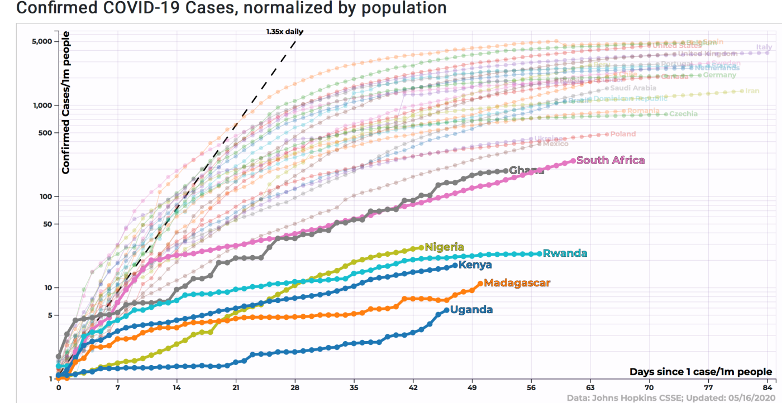

Uganda’s curve minus the cases from the neighbouring countries and other foreign countries but detected and treated in Uganda before the change of policy on this issue is as follows:

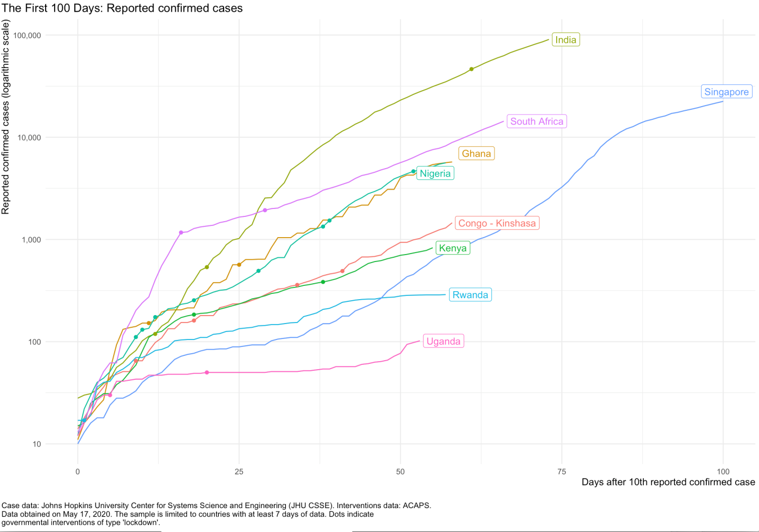

Thus, the strategy of lockdown has helped us to have a rough idea as to where the enemy is mainly coming from and also to prepare better. Where has the enemy been coming from? It seems, there are three answers to this. One, initially, the enemy was coming from Dubai, Europe, the USA, etc. We blocked that enemy by closing the Airport, suspending all passenger travel except for emergencies and humanitarian flights and closing our land and water borders for all passengers (vehicles-born, boats-born or pedestrians). Our powerful village Resistance Councils’ system, helped in guarding all the villages from infiltrations from the neighbouring countries. The few that sneaked in, were promptly discovered and handed over to the health authorities. Remember the two Barundi and their irresponsible bodaboda ally and the student from Bukoba, Tanzania and his family.

Secondly, the enemy is now coming from the cargo-drivers ─ mainly lorry drivers. As you heard, out of the total positive cases of 227 to-date detected in Uganda, 166 are lorry drivers. This is 73% of all the positive cases. I know how much the Ugandans are hostile to the policy of allowing the lorry drivers to continue to enter and leave Uganda. Many Ugandans wanted to block out and in, all the lorry drivers. However, as I told you, that would have been suicidal and more self-hurting (okwekuba endobo ─ kwetera endobo) than curative. War is not fought only by anger (obusungu) but also by wisdom (amagyezi). When we allowed the cargo drivers to continue coming, their problems to us notwithstanding, we knew it was a calculated but also a manageable risk. Why?
First of all, we need that cargo for our survival and even prosperity. Much of the inbound and outbound cargo is ours. 75% of the trucks are carrying Uganda’s cargo. All the other hinterland countries account for only 25%. It is, therefore, mainly our cargo that is involved. It is our coffee, it is our tea, it is our cement, it is our mitayimbwa (steel bars), it is our sugar, it is our maize, it is our milk products, etc., going to external markets. It is also our machinery, our raw-materials, our defence weapons, our other goods of commerce, our medical products, etc., coming from outside to strengthen us generally and also help us to fight this virus better. Therefore, it is a wrong strategy to block cargo and, besides, it is not necessary. Why? We can, as you have seen, be able to identify the sick from the healthy. The only problem that we are going to eliminate has been the delay in the testing. The method of allowing the drivers to enter and, then, get the results later, will be stopped.

This was in order to try and minimize the costs for the transporters. Of course, these costs, in the end, are passed on to the public and to the manufacturers. Since, however, the drivers and their employers seem not to be bothered with the concerns of the public and we, their leaders, we shall now not allow any lorry driver to enter Uganda or to leave the border area until the results have been received. There is a quick test known as the Gene-Xpert that takes only one hour for 32 tests. However, since we only have limited quantities of the cartridges that are needed for these machines to test for covid-19, we are concentrating them at Mutukula because there is less traffic there. Once we get more of these cartridges, we can quickly deploy more Gene-Xperts to other border points. Malaba already has 2 Gene-Xpert machines deployed but waiting for cartridges in order to start the testing. Once we get more of these, we can quickly test everywhere. The other alternative is H.E. Kenyatta’s plan of joint regional Health teams of: Uganda, Kenya, Rwanda, South Sudan and Congo DRC, testing these drivers at their respective points of origin, two times a month, so that they do not have to stop at the border. The new policy has already seen 14 Tanzanians, 16 Kenyans, 1 Rwandese, 1 Murundi and three Eritrean drivers, being turned back yesterday at the different border points. However, 21 Uganda drivers were taken to hospitals.

The medium term better solution, is to shift most of the cargo from the Lorries to the railway, at least, within the original East African Community countries of Kenya, Tanzania and Uganda. These have railway networks that could be revamped. Congo, South Sudan, Rwanda and Burundi will have to continue with the Lorries for now, but with the better solutions mentioned above. The additional plan for the Lorries is to have a convoy system ─ escorted from entry to exit or to the termination point if the cargo is destined to Uganda. In the meantime, however, all the drivers will stay at the border until they get their results.

Our strategy in this war is to avoid the sickness and survive as a country that can still function in normal ways of a semi-modern or even more modern country. It is not to avoid sickness and collapse. That would be suicide. We have lost US$1.6billion from tourism. We may lose US$1.3billion from the remittances of the Ugandans living abroad. We cannot lose forex from our coffee, our tea, our maize, our milk products, our cement, our mitayimbwa, our ceramic tiles, our soap and cooking oil exports, etc., in addition to failing to bring in raw-materials, machinery, pharmaceuticals, etc.
That is simply a wrong debate. The debate should not be on whether the cargo drivers should enter and exit. It should be on how these drivers should be handled.

The third route, the enemy (the virus) can use are infiltrators from the neighbouring countries that sneak in through the porous artificial borders. Fortunately, our powerful LC system, worried about the safety of themselves and their village mates, are reliable allies in this matter. They will expose any infiltration. Actually, the problem in this area, are sometimes, the corrupt security personnel if they are not supervised. It is the security personnel that sometimes collude with the smugglers. The RDCs should have close cooperation with the LCs. They will get everything. Even the corrupt security elements will be exposed. This third enemy route can, therefore, also be closed.

Apart from identifying the three main enemy entry points, the returnees, the lorry drivers and the persons from the neighbouring countries that are infiltrating through the porous borders, we have prepared the treatment centres in the following places: Naguru, Arua, Gulu, Lira, Soroti, Moroto, Mbale, Jinja, Entebbe, Masaka, Hoima, Mbarara, Kabale, Fort Portal and Mubende hospitals. Apart from Naguru, Soroti, Moroto and Mubende, all the other hospitals have so far managed and discharged or are still managing a number of cases. That is why we have not lost anybody yet and 63 people have been healed. The total beds in all these hospitals are 3,200 and each of the 16 hospitals will soon have a fully equipped ICU ward. Procurement is on-going. However, currently, on top of Mulago and the Women hospital, the other hospitals with ICU units are: Kabale, Mbarara, Hoima, Jinja; the others will get soon. We have 102 working ventilators at Mulago, 35 at regional referral hospitals and we are buying 145 by June, this year. Each Regional Referral Hospital will have at least 10 ventilators. Although our doctors have told me that waiting for patients to progress to the ventilators is a mistake. Moreover, the ventilators themselves can leave damage on the patient and many people on them do not recover. Our doctors’ strategy has been to intervene early and not allow patients to progress to the point of needing ventilators. This capacity is a good nucleus that can be scaled up by building tents in open spaces, converting stadia, etc., etc., if bigger numbers require attention.
Besides being more prepared on the medical side, our industries are getting more prepared to produce masks of all types; sanitizers; Personal Protective Equipment (scrub suits, face shields); and diagnostic testing kits; and even the medicines.

In the meantime, it is important to, again, remind ourselves of the basics concerning these diseases, epidemics or otherwise, past or present. In the case of many of these diseases, the way forward is simple: stop by vaccination, treatment or avoiding. We are working on the vaccine and so are other people in the World.

On the side of treatment, there are two parts: diagnosis using the different diagnostics, using the PCR (that looks for the core particles of the virus – the intestines), the antigen test (that looks for the envelope parts of the virus) and the IGM/IGG anti-body test (that looks for the IGM soldiers – the first soldiers deployed to fight the infection as soon as one gets it and the IGG soldiers that come in later for reinforcement and these remain for some time to keep the body protected). Our scientists supported by the Government, are working on all these efforts. What I do not want to hear of is the perpetual dependency of Uganda on others. That must end.

After the diagnosis, then, you get the treatment which involves three efforts: treating co-morbidities (the other diseases the patient may have ─ HIV, diabetes, blood-pressure, cancers, etc.); boosting the immune system of the patient so that it fights better (e.g. Vitamin-C, Vitamin D, Vitamin E and Zinc); and drugs to kill the virus itself. Our scientists are, again, working on all these. We have covered the two-thirds of this effort ─ treating the co-morbidities and boosting the immunity of the patient. That is why patients have recovered and we have not registered any covid-19 virus related death. Our scientists are also working on the remaining one third ─ the ability to kill the virus using dedicated medicines. The use of plasma from the recovered patients, is one of the solutions in attacking the virus. The survivors’ blood plasma contains soldiers (anti-bodies) that helped them to defeat the enemy. Treatment solutions will be built around those soldiers. The recovered patients should provide the plasma.

Right from the beginning, the quickest method we used to fight the disease, was prevention by avoiding ─ okwewala, okwetantara, Luo-gemeo, Lugbara-atrita, Ateso-acoikina. Avoiding how? As follows:

- Do not get near anybody coughing (kukorora) or sneezing (kwetsyamura);

- Do not shake hands or hug;

- Do not touch your mouth, your nose or your eyes with un-washed hands;

- Regularly sanitize all the surfaces that are touched by many people ─ table-tops, door handles, chairs, arm-rests, micro-phones, etc.;

- Wash your hands with soap and water or use sanitizers, regularly;

- After observation, the scientist have found out that even if you do not cough (kukorora) or sneeze (kwetsyamura), by merely talking (kugamba, kwogera, Luo-lok, Lugbara-eyoyozu, Ateso-einer) or simply breathing (kwitsya), if people are near you, you can infect them if you are sick and they are not.

That is how the extra mechanism of using the face masks (obukokolo) comes in as a crucial instrument in stopping the spread of the virus. The masks are three types: the N-95 which is for the people working in the intensive care units; the surgical mask; and the ordinary mask. The N-95 and the surgical masks are good for the use of the doctors because you use them only once and throw them away. It is the ordinary mask that is useful because it is a double-folded cloth with a soft tissue in the middle or a polypropylene sheet. Every day, you can remove the tissue or the polypropylene sheet, wash the mask and iron it with a hot flat-iron. The viruses will die. This mask must be won all the time you are in public and must cover the mouth and the nose whether you are sneezing, coughing, talking or just breathing normally. It is a very crucial instrument of prevention. Since many people were expressing concern that they cannot afford to buy these masks and also to ensure quality and avoid sharing, the Government has decided to provide them free of charge to all Ugandans of 6 years and above.
The children of less than 6 years, cannot safely wear these masks. Moreover, their lungs may, not cope with them. These masks, like the mosquito nets, will be distributed through the LC system: district, sub-county and village. We shall provide one mask per person of 6 years and above. They must be worn, all the time, when you are in public.

- Keeping social distance of, at least, 4 meters in public ─ tonsemberera.

- Good nutrition, including eating foods like Fruits (oranges, mangoes, lemons, bananas), Vegetables (carrots, ginger, garlic, greens), Proteins (meat, fish, beans, nuts), etc., to get sufficient source of Vitamin D ─ spend at least 1 hour in the sun.

I normally remind everybody that we, the Africans, are the original human beings that have been here for the last 4½ million years. The first vaccine, against small-pox (Omuze-Kawaali), was discovered by Edward Jenner in the year 1796. The last epidemic of small-pox here in Uganda, before colonialism, was in 1893.
My great-grand mother, Nyinanchweende, as well as my grand-fathers, were alive that time. The only solutions the people had against that epidemic were: avoiding (okwewala, okwetantara) by not going where an outbreak was reported; and strong immunity to defeat the disease. Some of my great grand-parents and grand-parents defeated the small-pox (Kacokora, Nyinanchweende, etc). I, myself, defeated the small-pox in 1963. The school had to close (Ntare School). Although the vaccine was long available by that time, nobody had bothered to immunize us. During many centuries, many diseases were simply avoided by human precautions. Diseases like yaws (ebinyoro), syphilis (ebihooya), leprosy (ebibeembe, ebigenge), etc., were controlled by avoiding (okwewala, okwetantara) and distancing (tonsemberera). In the Bible, in the Book of Luke chapter 17, verse 11-19, you remember the story of the 10 lepers. It says: “¹¹ Now on his way to Jerusalem, Jesus travelled along the border between Samaria and Galilee. ¹² As he was going into a village, ten men who had leprosy^{[a]} met him. They stood at a distance ¹³ and called out in a loud voice, “Jesus, Master, have pity on us!” ¹⁴ When he saw them, he said, “Go, show yourselves to the priests.” And as they went, they were cleansed. ¹⁵ One of them, when he saw he was healed, came back, praising God in a loud voice.
¹⁶ He threw himself at Jesus’ feet and thanked him—and he was a Samaritan. ¹⁷ Jesus asked, “Were not all ten cleansed? Where are the other nine? ¹⁸ Has no one returned to give praise to God except this foreigner?” ¹⁹ Then he said to him, “Rise and go; your faith has made you well.”
The crucial words here are: “they stood at a distance” (tonsemberera, otampika). This was 2000 years ago.

Therefore, of the three methods of dealing with diseases, vaccinations and treatment are very recent in the long history of man and livestock. The oldest method of confronting disease is prevention by avoiding and strengthening the immune system by good nutrition. As we look for the vaccine and better treatment methods, we should not forget that.

Hence, moving forward from the 20th of May, 2020, given the knowledge we now have and the capabilities we have as well as the limitations we continue to have, we shall move forward as follows:

In addition to the measures, we announced on the 4th of May, 2020, we now add the following measures in easing the lock-down:

1. The shops selling general merchandize will open provided they are not in the shopping malls, the shopping arcades and food markets. We cannot allow the opening of these because it is impossible to observe the social distancing in these shopping malls or arcades. That is why they should remain closed for now. As for the markets, we should not allow the mixing of selling food and non-food items again, until we get a vaccine or a clear treatment for this virus. You have seen how separating food-selling from the non-food operations, has helped us to go through the bad phase of this crisis. We should maintain it. The non-arcade and non-shopping malls shops that will open, must always observe the rules of social-distancing, all the time. Do not allow in many shoppers at the same time. Let them line outside, keeping the 4 meters distance and come in the shop, one by one.

2. Secondly, the heroic market women that have slept in the work places for all these days, will be allowed to go home and come back to work daily if they want to.

3. We shall allow the regulated opening of the public transport means of mini-buses, buses, taxis, provided they carry only one half of their normal capacity. We hope this can enable public transport travel, again, without the usual over-crowding which is very dangerous during such times as these. Remember that with the danger of this epidemic, the safest modes of transport are: bicycling, using a pikipiki if you are not carrying a passenger; walking; or if you have a private car. Especially the bicycles, they are good for health and also for the environment. We do not want to see brokers and hawkers in these bus parks and car parks for now. With the permitting of the public transport, exception must be made for the 40 districts that are next to our neighbouring countries. These districts are as indicated in the table below:

LIST OF BORDER LINE DISTRICTS
No. | REGION | DISTRICT | Total
 | Acholi | Amuru, Kitgum, Lamwo | 3
 | Ankole | Isingiro, Ntungamo, Rubirizi | 3
 | Buganda | Kyotera, Rakai | 2
 | Bukedi | Busia, Tororo, | 2
 | Bunyoro | Bulisa, Hoima, Kagadi, Kikube | 4
 | Bugisu | Bududa, Manafwa, Namisindwa | 3
 | Karamoja | Amudat, Kaboong, Karenga, Moroto, | 4
 | Sebei | Bukwo | 1
 | Rwenzori | Bundibugyo, Kasese, Ntoroko | 3
 | West Nile | Arua, Adjumani, Koboko, Maracha, Moyo, Nebbi, Pakwach, Yumbe, Zombo | 9
 | Kigezi | Kabale, Kanungu, Kisoro, Rubanda, Rukiga, Rukungiri | 6
 |  |  | 40

Neither public transport and nor private vehicles will be allowed to move around these districts for the next 21 days. Why? It is because infiltrations from the neighbouring countries, is still a serious pressure. With public and private transport in those border districts, that infiltration will be that much more facilitated. That infiltration can undo everything we have achieved. A few sick people from the neighbouring countries, using the fast means of either private or public transport, can easily get to the big population centres where identification is difficult. That is why we should not as yet allow the relaxation of the restrictions on both public and private transport in those border districts.

4. Since it is impossible to space out the passenger and the bodaboda driver, for now, the bodabodas and the tukutukus, will not be allowed to carry passengers. They should continue to carry cargo as they have been doing during the time of the lock-down.

5. Bars, night-clubs, gyms, saunas, public swimming pools and hair-salons, since they cannot easily observe the rules of tonsemberera, otampika, Luo-bed-mabor-ki-lawoti, Ateso-mam-ibun-eiduey-kede-enong, Lugbara-miesimimavuko, will not be allowed to open for another 21 days.

6. The International borders of Uganda and the Airport will remain closed so that we do not import additional cases from outside.

7. With Education, the only possible safe action we can do now, is to open for the end of educational phases candidate classes. These are: the P-7s; the S-IVs; the S-VIs; the under-graduate finalists; the tertiary college finalists; and the post-graduate finalists. There will be no first-term examinations in the schools. The schools should use all the time to prepare for the end of year final examinations. By opening for only the candidate classes, there will be enough space in the educational premises to avoid over-crowding and observe the social-distancing of 4 meters from person to person and yet the concerned learners will not miss that crucial stage in their educational journey. The rest of the learners, should be patient. It is better to stay alive than to lose one’s life in hasty actions in dangerous times like these ones. The Educational Institutions need two (2) weeks to prepare. Therefore, the date of opening should be the 4th of June, 2020. Since we are not allowing either private or public transport in the border districts, special arrangements will be made for candidates from those areas that need to go outside their districts for continuing with their studies.

8. Curfew from 1900hours (Saa moja ya usiku) until 0630 hours (Saa kuminambiri na nusu za usiku), remains in place for another 21 days.

9. Hotels and food restaurants can open as long as the clients observe social-distancing and there is no air-conditioning which spreads the virus.

10. People with private cars will be allowed to drive as long as the car does not carry more than 3 people, including the driver. If we had enough time and space, it may be better to restructure transport in the towns so as to emphasize bicycles, buses, trains, in addition to private cars. When there is a health crisis like this one, these means are safer than the others with proper regulation. The KCCA and the Ministry of Transport, should study how this can be done. We should have lanes for vehicles and pikipikis; lanes for bicycles; and lanes for pedestrians; and there should be no mixing of the 3. The phenomenon of pikipikis driving on side-walks meant for pedestrians, will no longer be allowed. However, this relaxation of restrictions on private transport does not extend to the 40 border districts.

All the other restrictions will remain in place for 21 days so that we see how these work.

Since all the measures I have outlined above are premised on the population observing all the dos and the don’ts that we have been telling you about ever-since the crisis started, including the compulsory wearing of masks while you are in the public, it is, therefore, crucial that these relaxation measures are timed to coincide with the universal provision of those masks. The earliest date possible is a week from (tomorrow), the 19th of May, 2020. This, therefore, means the 26th of May, as the best date for the commencement of the relaxation measures for public transport, the opening of shops, the driving of private cars, etc.

With these measures, it means that the three major sectors of the economy and society will now be fully operational. These are: agriculture that was never touched even in the lock-down time, industry (manufacturing) and ICT (Business Process Outsourcing (BPOs, Innovation hubs, etc). The services (transport, banks, hotels, etc.), will be the only sector that is only partially operational.
Some of the elements of the services sector, will continue to be shut down e.g. tourism because of the ban on international travel. With our primate tourist destinations like Bwindi (Mountain Gorillas) and Kibaale Forest Reserve (Chimpanzees), they cannot be opened because we do not want the virus to spread to our relatives, the Chimpanzees.

Then, there is the issue of the Ugandans caught by the pandemic abroad. This issue should be approached with the usual seriousness of the NRM, not the contemptible but very dangerous cheap populism of some of the actors. During the dangerous times in Uganda’s history, 1966 up to 1986, i.e. 20 years, alot of Ugandans fled the country in search of safety. When the NRM restored the safety of persons and property (Point No. 2 of the NRM 10 Points Programme distilled in the bush), many stayed abroad voluntarily to earn livelihood for their families and send money home. Indeed, they have been sending US$1.3 billion per annum back to Uganda, to their families, greater than the US$416million from coffee per year but lower than the US$1.6billion from tourism. Of course, our home-based sectors such as agriculture, the innovations of our scientists and manufacturing will earn much more than this if only the political class and the neo-colonial bureaucracy could either listen to our message or when they are forced to listen to our message. With value addition, coffee should be earning US$4billion, not a mere US$416million per year. Nevertheless, for now, we have about 170,000 Ugandans in North America (USA and Canada), 558,982 in Europe, 138,200 in the Middle East, 1.1million in Southern Africa, 250 in Nigeria, 400 in Algeria, 2,500 in China, etc. If all our people decided to come back in panic, without a vaccine and without a cheap reliable and affordable diagnostic test and without a dedicated treatment for the virus that can be deployed on a mass scale, how would the country be saved?

How would the base, Uganda, of that diaspora and the stayee populations be saved? You have seen how much trouble the lorry drivers are giving us.

Yet, the lorry drivers who come to and from Uganda in a month are not more than 100,000. When the crisis started, we concentrated on saving the base for the sake of the people inside and outside the country.

Thanks to God, our steps have been rewarded by not having the coffins I have been watching on TVs in the other countries. The Minister of Foreign Affairs and that of Health are this week preparing a Paper on how to handle this. I cannot accept the idea of cargo planes being used to transport passengers. This is different from passenger planes, e.g. air-bus, with some cargo space below. Given these big numbers, now that we seem to have stabilized the home situation, we should seriously and transparently discuss the issue of the diaspora if they want to come back in big numbers. Of course, we can say that the evacuees should pay for the tickets or the special flights. The problem, however, is not just paying for the air-travel.

The main factor is the health considerations ─ the fear of the spread of the virus when we do not yet have a vaccine and when we cannot yet handle too large numbers for treatment, the way we have handled the 63 that have recovered. It is the large numbers, without a vaccine and without treatment capacity for those large numbers. With malaria, we can treat large numbers at the same time. With corona, we cannot. Even quarantining. Can you quarantine 100,000 people in one area? With the 15million learners, our solution was dispersal.
Fortunately, we had our 7,304,100 million homesteads to disperse them to and we acted in time when the virus had not spread. We dispersed the learners into the 7 million homes because we were reasonably sure that the learners would not infect their families and vice-versa because, at that time, the virus had not spread to the population. Are you sure of the health status of the 2 million Ugandans in the diaspora that live in such highly infected countries? These are the issues we need to study seriously and not engage in shallow propagandizing.

The Ugandans in the diaspora are living in very highly infected countries. That is the issue that needs to be discussed rationally. Small numbers, using special passenger and not cargo flights, can be handled. The question is: “Which small groups and why?” The Paper of the Ministries of Health and Foreign Affairs, to which you should all contribute, will help us get correct answers.

I thank all of you.

18th May, 2020 - Nakasero

