ADDRESS
BY

H.E. YOWERI KAGUTA MUSEVENI
PRESIDENT OF THE REPUBLIC OF UGANDA

TO THE NATION

ON
COVID-19 PANDEMIC RESURGENCE
CURRENT STATUS OF THE PANDEMIC IN THE COUNTRY

6TH JUNE, 2021
NAKASERO

CURRENT STATUS OF THE PANDEMIC IN THE COUNTRY

Since my last address on COVID-19 on 29th May 2021, the COVID-19 situation has drastically changed. On 4th June 2021, the country registered the highest number of cases in a single day; 1,259 cases out of 7,424 tests done (17% Positivity Rate). There has been an upsurge in case patients since end March 2021 following a 3-month period (January, February, March 2021) of controlling the epidemic.

Currently, there is diffuse and sustained COVID-19 transmission in 81 districts where the highest burden districts: Kampala reporting an average of over 500 cases per day, followed by Wakiso and Gulu which have consistently reported over 100 cases per day.

Distribution of COVID-19 cases in the last 14 days (Cases: 8,163; Districts: 81)
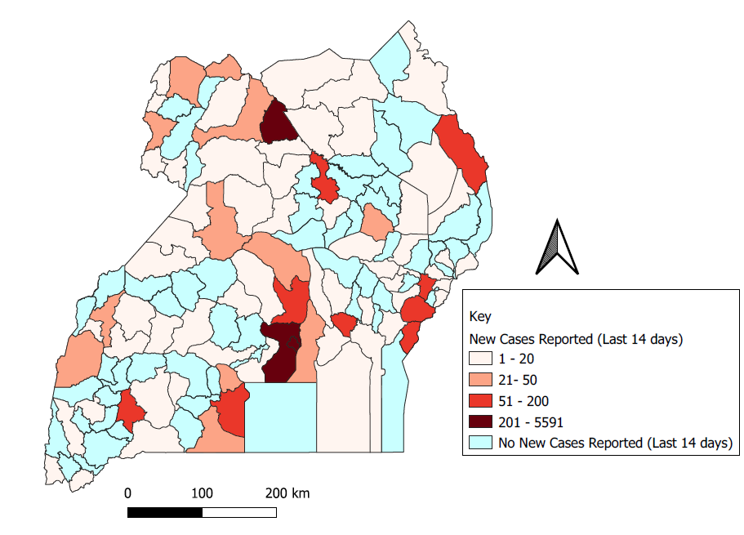
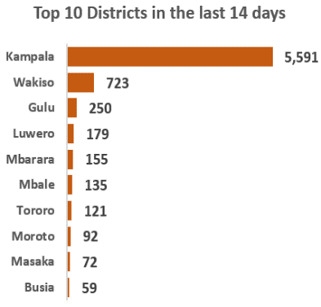

As of today, cumulative cases stand at 52,929, reported confirmed deaths at 374 and recoveries at 43,487. Currently, we have 634 patients (Severe: 277; Critical: 37) admitted at both public and private facilities. This means that only 8% of the cases confirmed in the last 14 days are on admission. We are concerned that this will exhaust the available bed space and oxygen supply in hospitals, unless we constitute urgent public health measures. In this wave, the intensity of severe and critically ill COVID-19 patients and deaths is higher than what we experienced in the 1st wave of the pandemic. In the previous wave, it took us 3 - 4 months to get to the current state of critical and severe patients, while in the 2nd wave, it has taken us less than 2 weeks to get to the same situation.

National epidemiological curve, March 2020 to date (N-52,929)

The most affected age group in this current wave are the young people aged, 20-39 years old with observed increasing transmission among the 10-19 yrs.

Distribution of confirmed COVID-19 cases by age-group (March 2021 to date; N=12,564)

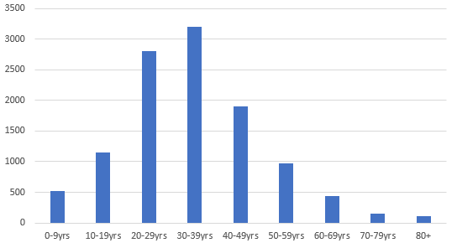

Distribution of confirmed COVID-19 cases on admission (N=634)

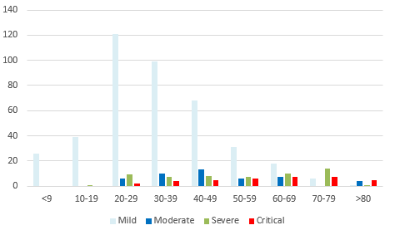
From the recent data on projection, this situation is expected to further escalate as a result of:

- Poor compliance by the population to follow the SOPs and my directives.

- There is an increased number of clusters of infections in schools since March 2021. A total of 948 reported cases in 43 schools from 22 districts. Kampala, Gulu, Masaka and Oyam districts combined constitute 61% of the reported cases in schools and higher institutions of learning. We believe this number is much higher, only that most schools are not reporting. The high number of infections in schools is largely attributed to:

- Poor compliance to SOPs;
- Inadequate sanitation facilities;
- Overcrowding in some schools;
- Failure by some school administration to monitor signs and symptoms among the learners and timely reporting;
- And concealment of infections in some schools by the school administrators.

- The entry of new variants that the Ministry of Health first reported at the beginning of March 2021, in addition to the original Wuhan strain, have been noticed. The variant strains specifically: the Indian variant (B.1.617), the South African variant (B.1.351) and the UK variant (B.1.1.7), are more aggressive and tend to cause sustained transmission and a shift of the most affected age-groups from older individuals to younger age groups.

This is because of the travelers that would come into the country with purported negative PCR test results, yet they were infected. To date, we have confirmed a total of 126 cases from travelers coming in from the airport. It is for this reason that Government, working with the private sector, instituted mandatory PCR testing at the airport for travelers from high-risk countries.

- The sustained transmission within the communities by infected persons who fail to adhere to the principles of home-based care, e.g, strict isolation from your family, adhering to full time use of face masks, hand washing and no movement out of home until one is declared COVID-19 negative. If they do not adhere to the Home-based care principles above, they pose a serious risk to the general population.

- There is generalized laxity in the response by most districts resulting into several clusters of transmission. The District Task Forces, chaired by the RDCs in all districts are the bedrock of the COVID-19 response. I am informed that most of these task forces are not meeting to guide the response.

Important to note is that since my last address on 29th May 2021, a total of 6,308 new cases from 57 districts, have been reported.

Currently, 81 districts have high sustained transmission. These include: Kampala, Wakiso, Gulu, Luwero, Mbarara, Mbale, Tororo, Moroto, Masaka, Busia, Nabilatuk, Amuru, Lira, Moyo, Arua, Lamwo, Kalungu, Rubirizi and Yumbe.

This resurgence, happened after Government had developed some capacity to manage COVID-19 in form of:

- Enhancement of skills and numbers of our Human Resources;
- Installation of new Intensive Care Unit/High Dependency Unit equipment;
- Procurement and installation of Oxygen plants in all Regional Referral Hospitals;
- Procurement of ambulances for emergency evacuation of patients; and
- Re-operationalization of Namboole to manage moderate to severe cases.

The current hospital beds to manage COVID-19 patients stand at 3,793 beds as summarized below:

SN | Treatment Unit | Standard Beds (n) | High Dependence  Unit (HDU) Beds (n) | Intensive Care Unit (ICU) Beds (n)
1. | Mulago National RRH | 600 | 300 | 27
2. | Mulago Women’s Hospital | - | 60 | -
3. | Regional Referral Hospitals | 900 | 115 | 150
4. | Namboole Treatment Unit | 1,300 | - | -
5. | Bombo Military Hospital | 120 | - | 10
6. | Private facilities (accredited 7) | 180 | - | 31
 | Total | 3,100 | 475 | 218

In addition to this, Government continues to mobilize Non-Traditional Treatment facilities in form of field hospitals to provide additional capacity for asymptomatic to mild and moderate cases.

In the worst-case scenario, should cases rapidly escalate and overwhelm the above bed capacity, Government will instal a 300-bed field hospital per Regional Referral Hospital, thus providing additional 4,500 beds.

The current rise in COVID-19 infections in the country can only be stopped if all the people of Uganda take personal responsibility for protecting themselves, their families and communities where they live and work. Uganda has well established structures for coordinating and governing the population such as LCs in all the villages, cultural and religious leaders and organized groups such as taxi or boda boda operators. We used these structures in the past to defeat HIV, Ebola and other epidemics.

In October 2020, the government launched the National Community Engagement Strategy for COVID-19 Response which has been distributed to all the districts in Uganda. This Strategy has guided on how to establish Village Covid -19 Task Forces (VCTFs) across all the 146 districts and how to provide Home Based Care when needed. I call upon all district leaders including LCs, cultural and religious leaders to use existing structures and systems to ensure that SOPs are observed in the villages and during village functions and the Village Health Teams are supported to mobilize people to report illness and support communities as guided in the MOH guidelines for home based care and support.

VACCINATION STATUS

Government has vaccinated a total of 748,676 people across the country; 712,681 people with the 1st dose and 35,995 with 2nd dose of AstraZenecca vaccine out of 964,000 doses received so far. Government appreciates the Ugandans’ enthusiasm to access the vaccine since my last address: 86,377 people have been vaccinated in a period of 7 days in comparison to 78,791 vaccinated the previous 7 days.

Government is committed to vaccinate all the 21.9 million eligible Ugandans, starting with the priority groups of 4.8 million people. These priority groups are: health workers – 150,000, teachers – 550,000; security personnel- 250,000; the elderly (all those above 50 years old)- 3,340,000; and people who have other diseases like cancer, high blood pressure, diabetes, liver, heart and kidney disease – 500,000.

Uganda vaccination roll out efforts have been hampered by the global vaccine shortages and amplified by resurgence of COVID-19 in India since February 2021. This situation in India, given its large population, has delayed the global vaccine delivery commitments to countries on time. However, Government is making all attempts to ensure that we secure additional doses to cover all the targeted groups.

Uganda is expecting to receive additional 175,000 doses of the vaccine through the COVAX Facility this week. In addition, Government will secure 300,000 doses of Sinovac vaccine donated by our friends, the Chinese Government.

I would like to remind you all, that COVID-19 control and prevention is a responsibility of everyone. I, therefore, urge all Ugandans to adhere to the COVID-19 SOPs: wash hands with soap and water frequently, wear face masks, social distancing, avoid mass gatherings, avoid touching your mouth, nose and eyes.

Avoid closed spaces (open windows fully), avoid crowds (markets, malls), avoid individuals with signs and symptoms of COVID-19 or ordinary senyiga (cold).

Good health, physical exercises, good nutrition and exposure to sunshine, have been shown to be beneficial in limiting COVID-19 transmission and severe disease.

In addition to our natural foods, we should emphasize plenty of fruits rich in Vitamin C (Lemon, orange juice, limes, tomatoes, pineapples e.t.c) and vegetables. Vitamin D is essential for reducing the severity of COVID-19. It is, therefore, important that we add meat (especially beef liver), eggs, fatty fish such as Nile Perch (especially the skin and the fish eggs) and all other sources of Vitamin D, in addition to exposure to the morning sun. The other sources of vitamin D, are: white beans, soya beans and Soya milk, sun dried mushrooms, and some vegetables such as spinach and Okra.

In light of the above and with guidance from the National Task Force and the Scientists, Government has revised the control measures to address the current situation as follows:

SN | New Presidential Directives as of 6th June 2021
1. | All schools and institutions of higher learning to close for 42 days effective 8 am, 7th June 2021.
2. | All teachers to fully get vaccinated before they are accepted in schools.
3. | Communal prayers in Mosques, Churches or in Stadia and other open-air, venues are suspended for 42 days.
4. | Online prayers are encouraged.
5. | Public and Cultural gatherings or Conferences, EXCEPT for the sitting of the Cabinet, Legislature and Judiciary, are hereby suspended for 42 days.
6. | Travel from Category 1 countries, as defined by the Ministry of Health, remain suspended except returning Ugandans. At the moment, only India is listed as category A.
7. | Agricultural activities which are: cultivating or ploughing gardens, herding livestock (whether free-range or zero grazing) and fishing for fish-farming to continue because, fortunately, most of them do not encourage crowding.
8. | The non-agricultural activities that will be allowed to continue are: factory activities, construction activities, shopping malls, super-markets to continue while observing SOPs issued by the Ministry of Health.  These gathering points such as factories hotels, large plantations, markets, taxi-parks, etc., should be allowed to operate under strict observance of SOPS.  These must observe strict SoPs, failure to comply within a week will lead to complete closure.
9. | Marriage ceremonies, parties, and all other social gatherings are only allowed with a maximum of 20 people under strict observance of SOPs.  House parties are strictly banned and this must be enforced without fail.  All guests should wear masks and keep physical distance.
10. | Number of persons at burials, vigils and funerals should NOT exceed 20 people.  All should wear masks and socials distance.
11. | Weekly non-food markets (Mibuulo Markets) are suspended for 42 days throughout the country.
12. | Also suspended for 42 days are the monthly cattle auction Markets ebikomera.
13. | All public transport (Buses, Taxis, Boda Bodas) between and across districts are suspended for 42 days effective 10th June 2021. This is to allow our children to go home.
14. | All inter district travel banned except travel within Kampala Metropolitan (Kampala, Wakiso, Mukono).
15. | Exemption for Inter district travel and movement of vehicles are:  - Cargo trucks  - Registered tourist vehicles  - Essential and Emergency Services vehicles
16. | Public transport within the same district is allowed with strict observance of SOPs as previously described.  NB:  Failure to strictly observe the SOPs in public transport sector will lead to total suspension of public transport.
17. | Cargo tucks are allowed only 2 people.
18. | Tourist vehicles must observe the SOPs as spelt out.
19. | Bars, discos, music shows, cinemas and concerts remain closed.
20. | Sports events will operate under strict observance of SOPs with no spectators, ALL players must have a negative PCR test.
21. | All public places (markets, Offices, shopping malls) are directed to maintain strict hygiene, ensure people coming in are sanitized before entry, physical distancing and appropriate use of face masks at all times.
22. | Encourage people to work from home whenever possible and revert to 30% physical presence at workplace for 42 days.
23. | Institutions, Organizations and workplaces to have person/s dedicated to compliance.
24. | Private vehicles should be restricted to not more than 3 people including the driver.
25. | Ambulances, security vehicles and garbage collection vehicles are allowed to operate normally.
26. | Shopping arcades, hardware shops and any other commercial entity to operate under strict observance of SoPs and must close at 7pm countrywide. Failure to comply will lead to total closure.  Owners and managers will be held liable for breach of SoPs.
27. | Exception be given to Pharmacies to operate beyond 7 pm.
28. | Supermarkets will remain open and operate with strict observance of SoPs and close at 7pm.  Owners must enforce the use of masks and sanitizers in the workplace at all times.
29. | The food markets should continue operating but enforce SoPs.  The market leaders will be held liable for non-compliance to SoPs.
30. | Salons, lodges and garages are allowed to operate up to 7 pm with strict SoPs.
31. | Lodges should be allowed to operate but the bars in these places should not be operational.
32. | Factories are allowed to continue operating under strict observance of SoPs and where need arises work in shifts.
33. | Construction sites are allowed to continue under strict observance of SoPs.
34. | Lorries should not have more than two persons.
35. | We shall continue to work with the EAC member states to strengthen cross-border surveillance.
36. | Private cars are allowed to cross the border provided they observe SoPs and occupants have a negative PCR test result.
37. | Curfew shall remain at 21:00 HRS to 05:30 HRS and vigorously enforced except for cargo trucks, lorries, pick-ups, trains and aircrafts.
38. | For health emergencies during curfew, this will be dealt with by security on case by case basis.
39. | Boda-Bodas are allowed to transport goods and/or one passenger up to 6 pm for the next 42 days.  Failure to comply within one week will lead to complete closure.
40. | Enforce directive and the responsibility should lie with owners of premises and with security.

Violation of these measures will lead to fines that will be given out soon in a Statutory Instrument signed by the Permanent Secretary (PS) Treasury. Those who do not care about the health of Ugandans will pay financially.

All the above directives, except where explicitly stated, take IMMEDIATE EFFECT.

Government will continuously observe the compliance and make necessary adjustments accordingly.

The enforcement of the above directives does not only lie with the law enforcers but also the owners of public transport organizations, owners of premises and individuals. If you fail to comply within one week, I will enforce total lockdown.

