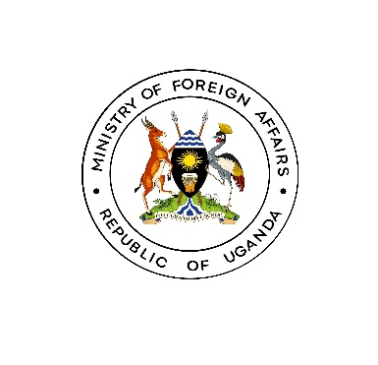
MEDIA RELEASE

Entebbe: May 23, 2024

MINISTRY OF FOREIGN AFFAIRS SUCCESSFULLY REPATRIATES TRAFFICKED UGANDANS FROM MYANMAR.

Today Thursday May 23rd 2024, the Ministry of Foreign Affairs is pleased to announce the successful repatriation of some of the Ugandan citizens who were victims of human trafficking in Myanmar.

This milestone was achieved through concerted efforts by various government agencies and international partners, demonstrating the Uganda Foreign Service’s commitment to protecting Ugandans abroad and combating human trafficking.

Speaking at Entebbe International Airport while receiving the returning VOT, the Permanent Secretary Mr. Bagiire Vincent Waiswa, urged Ugandans to be cautious of fraudulent employment schemes. “The Ministry, working with the Ministry of Internal Affairs continues to work on preventing human trafficking through regional and international cooperation. He emphasized.

On the sidelines of the 19th Summit of the Non-Aligned Movement held in Kampala in January 2024, Hon. John Mulimba, Minister of State for Foreign Affairs for Regional Cooperation, along with Ambassador Dr. Betty Bigombe, Ambassador of the Republic of Uganda to Thailand with residence in Kuala Lumpur, met with Myanmar's Deputy Minister of Foreign Affairs, H.E. Mr. U Than Swe, to raise concerns about the safety, rescue and return of the incarcerated Ugandan citizens.

The issue came to light in 2023 when reports surfaced of about twenty-three (23) Ugandans being held in Tachileik, Myanmar, after being lured with promises of high-paying jobs. They were subsequently forced into crypto-currency scams and smuggled across borders. The Government of Uganda, in collaboration with the Uganda High Commission in Kuala Lumpur, the Ministry of Internal Affairs, and the Office of the Prime Minister, initiated a series of diplomatic engagements with the Government of Myanmar, leading to an agreement to release the Ugandans.

PS Bagiire extended the gratitude of the people of Uganda to the International Organisation for Migration (IOM) for providing crucial support, such as shelter and travel arrangements back to Uganda. He also graciously thanked the Government of Thailand, which generously waived all overstay visa fees and pardoned those rescued repatriates without work permits.

“Following their release, the victims were sheltered at the Thailand-Myanmar border, with assistance from the Thai government and the International Organization for Migration (IOM). Thai authorities confirmed the victims' status as trafficking survivors, enabling the repatriation process to commence”, the Permanent Secretary highlighted.

“The Ministry of Foreign Affairs extends heartfelt thanks to the Government of Thailand, the IOM, and particularly H.E. President Museveni, for their invaluable support. Special recognition goes to Amb. Dr. Betty Bigombe for her relentless efforts.” PS Bagiire further remarked.

The Ministry of Foreign Affairs reaffirms its dedication to protecting Ugandan citizens abroad and addressing human trafficking with the seriousness it deserves. With collective effort and unwavering commitment, we can prevent and manage human trafficking, safeguarding our children, youth, and vulnerable populations.

Ministry of Foreign Affairs
KAMPALA, UGANDA

