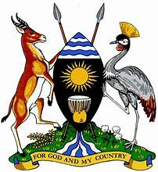
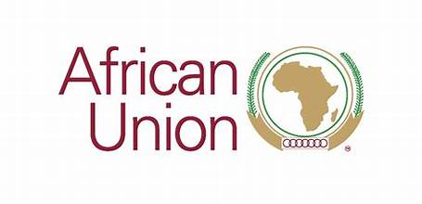

FOR IMMEDIATE RELEASE

Date: October 31, 2023
UGANDA- AFRICAN UNION COMMISSION CO-HOSTS AFRICA YOUTH DAY 2023 CELEBRATIONS IN KAMPALA- UGANDA

Uganda Hosts Africa Youth Day Celebrations at Sheraton Hotel Kampala on November 1, 2023

KAMPALA, UGANDA - The Republic of Uganda, in collaboration with the African Union and various esteemed development partners, is thrilled to announce the grand celebration of Africa Youth Day 2023. This significant event will take place on November 1, 2023, at the prestigious Sheraton Hotel in Kampala, Uganda.

Africa Youth Day is a day dedicated to celebrating the energy, determination, triumph, creativity, and resilience of the African youth across the African continent and in the diaspora. It highlights their invaluable contributions to the socio-economic development of our nations and their role in building a brighter future.

This year's theme, "1 Million Next Level is Knocking: Youth-led Movements that Transcend Borders," underscores the importance of youth-led movements that transcend borders, working collectively towards a better future and the attainment of the Africa we want and the aspirations of the Agenda 2063..

The celebration is organized with the valuable and continued support from development partners, including the European Union in Uganda, UNFPA Uganda, Plan International, Youth for Tax Justice Network Uganda, Habitat for Humanity, and the Africa Youth Federation. The National Youth Council of Uganda is also a key contributor to the event, ensuring the success of Africa Youth Day 2023.

The celebrations will include a series of engaging activities, panel discussions, workshops, and entertainment, all aimed at empowering and inspiring young people to realize their full potential. Distinguished speakers and experts will participate in discussions covering a wide range of topics, under the thematic area of education and skills development, inclusive therewith, employment, entrepreneurship, and social innovation. This will suffice as one of the pre-engagements on the roadmap towards the unveiling of the Africa Union’s theme for the year 2024 that will focus on building resilient and inclusive education.

This celebration is inline with His Excellency the President Yoweir Kaguta Museveni, President of Uganda- commitment to youth engagement and support, in order to provide platforms for ideation, interrogation of various approaches to issues of human capital development as well as the role of youth in National and Continental Development. On the 4th July 2022 during the 3rd APRM Continental Youth Symposium, President Museveni launched the 1 Million Next Level Initiative at country level and established a steering committee to oversee its implementation. Uganda became the first country to undertake this process, now followed by the Republic of Burundi and other African nations are since engaging with the African Union Commission as a continental cascading secretariat to undertake similar processes. This initiative is borne out of His Excellency Moussa Faki Mahamat, African Union Commission Chairperson’s desire to bring the commission closer to young people and provide a harmonized framework for continental youth development. The 1 Million Next Level Initiative has now succeed the African Plan of Action for Youth Empowerment until 2030
Africa Youth Day 2023 promises to be an event filled with inspiration, knowledge-sharing, and a sense of unity among the youth. We encourage all young individuals, stakeholders, and organizations to attend and be part of this memorable occasion.

We extend our deepest gratitude to our development partners, the African Union, and all those who have contributed to making this event possible. Together, we are working towards a brighter and more prosperous future for the youth of Africa.

We therefore invite Uganda and other African Youths to join, unite and celebrate the potential and promise of the youth of Africa as they lead movements that transcend borders towards the next level of progress. We look forward to your participation in this momentous event.

For Media inquiries, please contact: Ms. Janice Khumalo, African Union Commission +27 610537956 and Mr. Deo Otim, Government Citizenship Interaction Center (GCIC)- State House +256777972139

Additional Enquiries, please contact: Mr. Daniel Obal, Senior Presidential Aide Incharge Youth Affairs

Jointly issued: Government of the Republic of Uganda and the African Union Commission.

